**Sign Up / Login Module**

**register.html**

<div class="wrapper">

<div class="title-text">

<div class="title login">Login Form</div>

<div class="title signup">Signup Form</div>

</div>

<div class="form-container">

<div class="slide-controls">

<input type="radio" name="slide" id="login" checked>

<input type="radio" name="slide" id="signup">

<label for="login" class="slide login">Login</label>

<label for="signup" class="slide signup">Signup</label>

<div class="slider-tab"></div>

</div>

<div class="form-inner">

<form action="#" class="login">

<div class="field">

<input type="text" placeholder="Email Address" required>

</div>

<div class="field">

<input type="password" placeholder="Password" required>

</div>

<div class="pass-link"><a href="#">Forgot password?</a></div>

<div class="field btn">

<div class="btn-layer"></div>

<input type="submit" value="Login">

</div>

<div class="signup-link">Not a member? <a href="">Signup now</a></div>

</form>

<form action="#" class="signup">

<div class="field">

<input type="text" placeholder="Email Address" required>

</div>

<div class="field">

<input type="password" placeholder="Password" required>

</div>

<div class="field">

<input type="password" placeholder="Confirm password" required>

</div>

<div class="field btn">

<div class="btn-layer"></div>

<input type="submit" value="Signup">

</div>

</form>

</div>

</div>

</div>

**style.css**

@import url('https://fonts.googleapis.com/css?family=Poppins:400,500,600,700&display=swap');

*{ margin: 0; padding: 0; box-sizing: border-box; font-family: 'Poppins', sans-serif;

}

html,body{

display: grid; height: 100%; width: 100%; place-items: center; background: -webkit-linear-gradient(left, #003366,#004080,#0059b3

, #0073e6);

}

::selection{ background: #1a75ff; color: #fff;

}

.wrapper{ overflow: hidden; max-width: 390px; background: #fff; padding: 30px; border-radius: 15px;

box-shadow: 0px 15px 20px rgba(0,0,0,0.1);

}

.wrapper .title-text{ display: flex; width: 200%;

}

.wrapper .title{ width: 50%; font-size: 35px; font-weight: 600; text-align: center; transition: all 0.6s cubic-bezier(0.68,-0.55,0.265,1.55);

}

.wrapper .slide-controls{ position: relative; display: flex; height: 50px; width: 100%; overflow: hidden; margin: 30px 0 10px 0; justify-content: space-between; border: 1px solid lightgrey; border-radius: 15px;

}

.slide-controls .slide{ height: 100%; width: 100%; color: #fff; font-size: 18px; font-weight: 500; text-align: center; line-height: 48px; cursor: pointer; z-index: 1;

transition: all 0.6s ease;

}

.slide-controls label.signup{ color: #000;

}

.slide-controls .slider-tab{ position: absolute; height: 100%; width: 50%; left: 0; z-index: 0; border-radius: 15px; background: -webkit-linear-gradient(left,#003366,#004080,#0059b3

, #0073e6); transition: all 0.6s cubic-bezier(0.68,-0.55,0.265,1.55);

}

input[type="radio"]{

display: none;

}

#signup:checked ~ .slider-tab{ left: 50%;

}

#signup:checked ~ label.signup{ color: #fff; cursor: default; user-select: none;

}

#signup:checked ~ label.login{ color: #000;

}

#login:checked ~ label.signup{ color: #000;

}

#login:checked ~ label.login{ cursor: default; user-select: none;

}

.wrapper .form-container{ width: 100%; overflow: hidden;

}

.form-container .form-inner{ display: flex; width: 200%;

}

.form-container .form-inner form{ width: 50%;

transition: all 0.6s cubic-bezier(0.68,-0.55,0.265,1.55);

}

.form-inner form .field{ height: 50px; width: 100%; margin-top: 20px;

}

.form-inner form .field input{ height: 100%; width: 100%; outline: none; padding-left: 15px; border-radius: 15px; border: 1px solid lightgrey; border-bottom-width: 2px; font-size: 17px; transition: all 0.3s ease;

}

.form-inner form .field input:focus{ border-color: #1a75ff;

/* box-shadow: inset 0 0 3px #fb6aae; */

}

.form-inner form .field input::placeholder{ color: #999; transition: all 0.3s ease;

} form .field input:focus::placeholder{

color: #1a75ff;

}

.form-inner form .pass-link{

margin-top: 5px;

}

.form-inner form .signup-link{ text-align: center; margin-top: 30px;

}

.form-inner form .pass-link a,

.form-inner form .signup-link a{ color: #1a75ff; text-decoration: none;

}

.form-inner form .pass-link a:hover,

.form-inner form .signup-link a:hover{ text-decoration: underline;

}

form .btn{

height: 50px; width: 100%; border-radius: 15px; position: relative; overflow: hidden;

}

form .btn .btn-layer{

height: 100%; width: 300%; position: absolute; left: -100%; background: -webkit-linear-gradient(right,#003366,#004080,#0059b3

, #0073e6); border-radius: 15px; transition: all 0.4s ease;;

}

form .btn:hover .btn-layer{ left: 0;

}

form .btn input[type="submit"]{

height: 100%; width: 100%; z-index: 1; position: relative; background: none; border: none; color: #fff; padding-left: 0; border-radius: 15px; font-size: 20px; font-weight: 500; cursor: pointer;

}

**function.js**

const loginText = document.querySelector(".title-text .login"); const loginForm = document.querySelector("form.login"); const loginBtn = document.querySelector("label.login"); const signupBtn = document.querySelector("label.signup"); const signupLink = document.querySelector("form .signup-link a"); signupBtn.onclick = (()=>{

loginForm.style.marginLeft = "-50%"; loginText.style.marginLeft = "-50%";

});

loginBtn.onclick = (()=>{

loginForm.style.marginLeft = "0%"; loginText.style.marginLeft = "0%";

});

signupLink.onclick = (()=>{

signupBtn.click(); return false;

});

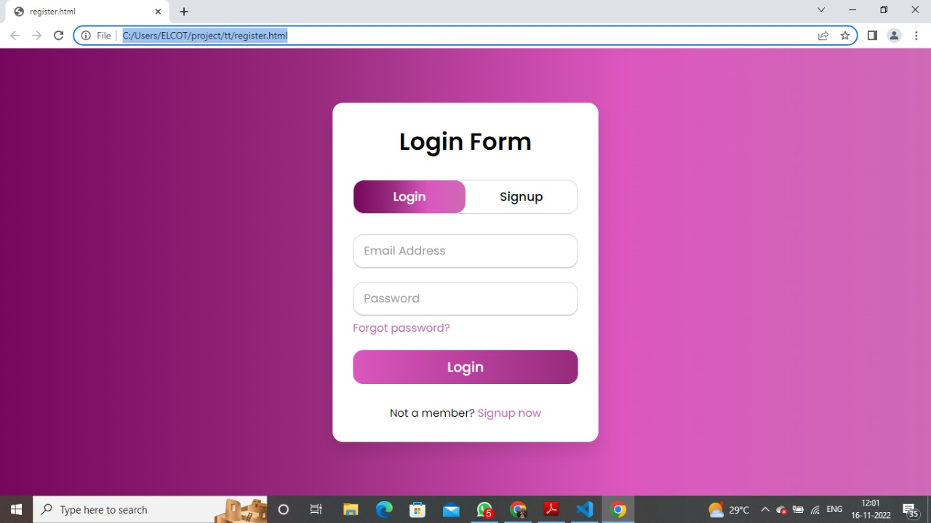

**Image Upload Module**

# imageUpload.html

<div class="wrapper">

<div class="title-text">

<div class="title login">Image Upload Form</div>

</div><br>

<form action="#" class="login">

<input type="file"><br><br>

<div class="field btn">

<div class="btn-layer"></div>

<input type="submit" value="Upload"><br>

</div>

</form>

</div>

</div>

</div>

# imup.css

@import url('https://fonts.googleapis.com/css?family=Poppins:400,500,600,700&display=swap');

*{ margin: 0; padding: 0; box-sizing: border-box; font-family: 'Poppins', sans-serif;

}

html,body{

display: grid; height: 100%; width: 100%; place-items: center;

background: -webkit-linear-gradient(left, #003366,#004080,#0059b3

, #0073e6);

}

::selection{ background: #1a75ff;

color: #fff;

}

.wrapper{ overflow: hidden; max-width: 390px; background: #fff; padding: 30px; border-radius: 15px; box-shadow: 0px 15px 20px rgba(0,0,0,0.1);

}

.wrapper .title-text{ display: flex; width: 200%;

}

.wrapper .title{ width: 50%; font-size: 35px; font-weight: 600; text-align: center; transition: all 0.6s cubic-bezier(0.68,-0.55,0.265,1.55);

}

.wrapper .slide-controls{ position: relative; display: flex; height: 50px; width: 100%; overflow: hidden; margin: 30px 0 10px 0; justify-content: space-between; border: 1px solid lightgrey; border-radius: 15px;

}

.slide-controls .slide{ height: 100%; width: 100%;

color: #fff; font-size: 18px; font-weight: 500; text-align: center; line-height: 48px; cursor: pointer; z-index: 1;

transition: all 0.6s ease;

}

.slide-controls label.signup{ color: #000;

}

.slide-controls .slider-tab{ position: absolute; height: 100%; width: 50%;

left: 0; z-index: 0; border-radius: 15px; background: -webkit-linear-gradient(left,#003366,#004080,#0059b3

, #0073e6); transition: all 0.6s cubic-bezier(0.68,-0.55,0.265,1.55);

}

input[type="radio"]{

display: none;

}

#signup:checked ~ .slider-tab{

left: 50%;

}

#signup:checked ~ label.signup{ color: #fff; cursor: default; user-select: none;

}

#signup:checked ~ label.login{ color: #000;

}

#login:checked ~ label.signup{ color: #000;

}

#login:checked ~ label.login{ cursor: default; user-select: none;

}

.wrapper .form-container{ width: 100%; overflow: hidden;

}

.form-container .form-inner{ display: flex; width: 200%;

}

.form-container .form-inner form{ width: 50%; transition: all 0.6s cubic-bezier(0.68,-0.55,0.265,1.55);

}

.form-inner form .field{ height: 50px; width: 100%; margin-top: 20px;

}

.form-inner form .field input{ height: 100%; width: 100%; outline: none; padding-left: 15px; border-radius: 15px; border: 1px solid lightgrey; border-bottom-width: 2px; font-size: 17px; transition: all 0.3s ease;

.form-inner form .field input:focus{ border-color: #1a75ff;

/* box-shadow: inset 0 0 3px #fb6aae; */

}

.form-inner form .field input::placeholder{ color: #999; transition: all 0.3s ease;

} form .field input:focus::placeholder{

color: #1a75ff;

}

.form-inner form .pass-link{ margin-top: 5px;

}

.form-inner form .signup-link{ text-align: center; margin-top: 30px;

}

.form-inner form .pass-link a,

.form-inner form .signup-link a{ color: #1a75ff; text-decoration: none;

}

.form-inner form .pass-link a:hover,

.form-inner form .signup-link a:hover{ text-decoration: underline;

}

form .btn{

height: 50px; width: 100%; border-radius: 15px; position: relative; overflow: hidden;

} form .btn .btn-layer{

height: 100%; width: 300%; position: absolute; left: -100%; background: -webkit-linear-gradient(right,#003366,#004080,#0059b3

, #0073e6); border-radius: 15px; transition: all 0.4s ease;; form .btn:hover .btn-layer{ left: 0;

}

form .btn input[type="submit"]{

height: 100%; width: 100%; z-index: 1; position: relative; background: none; border: none; color: #fff; padding-left: 0; border-radius: 15px; font-size: 20px; font-weight: 500; cursor: pointer;

}

body {

display: grid; height: 100vh; place-items: center;

}

input::file-selector-button {

background-image: linear-gradient( to right, #ff7a18,

#af002d,

#319197 100%,

#319197 200%

);

background-position-x: 0%; background-size: 200%; border: 0; border-radius: 8px; color: #fff;

padding: 1rem 1.25rem; text-shadow: 0 1px 1px #333; transition: all 0.25s;

} input::file-selector-button:hover {

background-position-x: 100%; transform: scale(1.1);

}

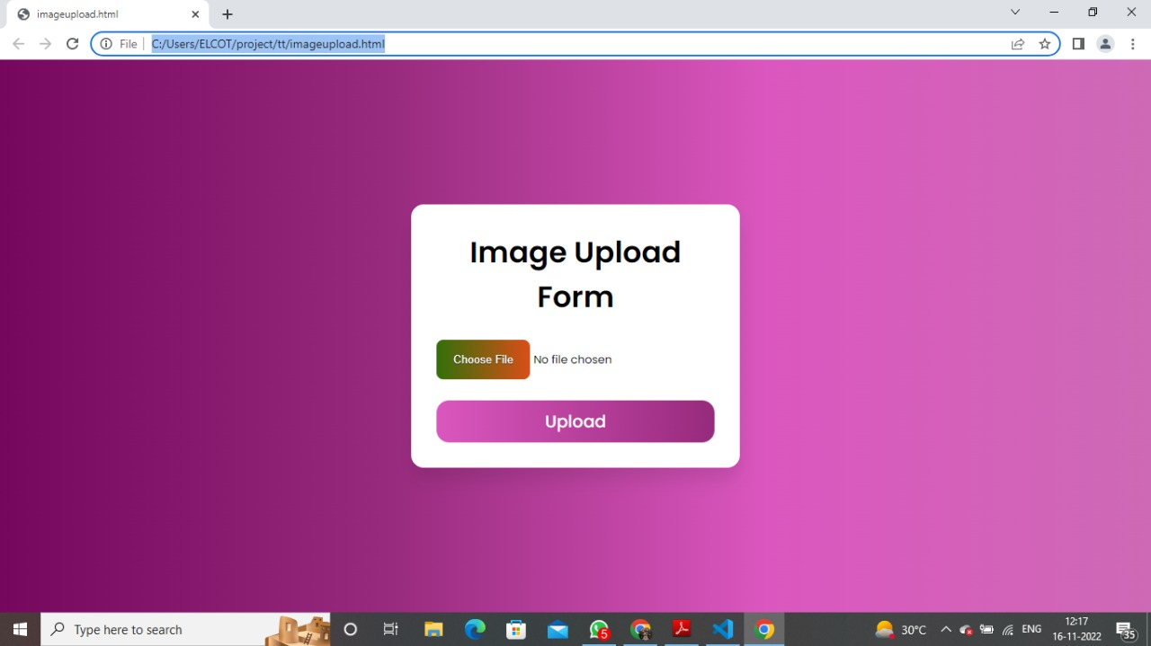

**Food Result Module**

# foodResult.html

<div class="wrapper">

<div class="title-text">

<div class="title signup">Food Result</div>

</div>

<div class="form-container">

<div class="form-inner">

<form action="#" class="login">

<div class="field btn">

<div class="btn-layer"></div>

<input type="submit" value="Vegetables and Juice">

</div><br>

<img src="https://images.unsplash.com/photo-1540189549336-e6e99c3679fe?ixlib=rb-4.0.3&ixid=Mn wxMjA3fDB8MHxleHBsb3JlLWZlZWR8NXx8fGVufDB8fHx8&w=1000&q=80" alt="Girl in a jacket" width="330" height="300">

<div class="field btn">

<div class="btn-layer"></div>

<input type="submit" value="Nutritional Facts">

</div>

<div class="signup-link">Calories <a href="">65 calories</a></div>

<div class="signup-link">Protein <a href="">2.9 g</a></div>

<div class="signup-link">Carbohydrate <a href="">13 g</a></div>

<div class="signup-link">Fat <a href="">0.2 g</a></div> </form>

</div>

</div>

</div>

# fore.css

@import url('https://fonts.googleapis.com/css?family=Poppins:400,500,600,700&display=swap');

*{ margin: 0; padding: 0; box-sizing: border-box;

font-family: 'Poppins', sans-serif;

}

html,body{

display: grid; height: 100%; width: 100%; place-items: center; background: -webkit-linear-gradient(left, #003366,#004080,#0059b3

, #0073e6);

}

::selection{ background: #1a75ff; color: #fff;

}

.wrapper{ overflow: hidden; max-width: 390px; background: #fff; padding: 30px; border-radius: 15px;

box-shadow: 0px 15px 20px rgba(0,0,0,0.1);

}

.wrapper .title-text{ display: flex; width: 200%;

}

.wrapper .title{ width: 50%; font-size: 35px; font-weight: 600; text-align: center; transition: all 0.6s cubic-bezier(0.68,-0.55,0.265,1.55);

}

.wrapper .slide-controls{ position: relative; display: flex; height: 50px; width: 100%; overflow: hidden; margin: 30px 0 10px 0; justify-content: space-between; border: 1px solid lightgrey; border-radius: 15px;

}

.slide-controls .slide{ height: 100%; width: 100%; color: #fff; font-size: 18px; font-weight: 500; text-align: center; line-height: 48px; cursor: pointer; z-index: 1;

transition: all 0.6s ease;

}

.slide-controls label.signup{ color: #000;

}

.slide-controls .slider-tab{ position: absolute; height: 100%; width: 50%; left: 0; z-index: 0; border-radius: 15px; background: -webkit-linear-gradient(left,#003366,#004080,#0059b3

, #0073e6); transition: all 0.6s cubic-bezier(0.68,-0.55,0.265,1.55);

}

input[type="radio"]{

display: none;

}

#signup:checked ~ .slider-tab{ left: 50%;

}

#signup:checked ~ label.signup{ color: #fff; cursor: default; user-select: none;

}

#signup:checked ~ label.login{ color: #000;

}

#login:checked ~ label.signup{ color: #000;

}

#login:checked ~ label.login{

cursor: default; user-select: none;

}

.wrapper .form-container{ width: 100%; overflow: hidden;

}

.form-container .form-inner{ display: flex; width: 200%;

}

.form-container .form-inner form{ width: 50%;

transition: all 0.6s cubic-bezier(0.68,-0.55,0.265,1.55);

}

.form-inner form .field{ height: 50px; width: 100%; margin-top: 20px;

}

.form-inner form .field input{ height: 100%; width: 100%; outline: none; padding-left: 15px; border-radius: 15px; border: 1px solid lightgrey; border-bottom-width: 2px; font-size: 17px; transition: all 0.3s ease;

}

.form-inner form .field input:focus{ border-color: #1a75ff;

/* box-shadow: inset 0 0 3px #fb6aae; */

}

.form-inner form .field input::placeholder{ color: #999; transition: all 0.3s ease;

} form .field input:focus::placeholder{

color: #1a75ff;

}

.form-inner form .pass-link{ margin-top: 5px;

}

.form-inner form .signup-link{ text-align: center; margin-top: 30px;

}

.form-inner form .pass-link a,

.form-inner form .signup-link a{ color: #1a75ff; text-decoration: none;

}

.form-inner form .pass-link a:hover,

.form-inner form .signup-link a:hover{ text-decoration: underline;

}

form .btn{

height: 50px; width: 100%; border-radius: 15px; position: relative; overflow: hidden;

} form .btn .btn-layer{

height: 100%; width: 300%; position: absolute; left: -100%; background: -webkit-linear-gradient(right,#003366,#004080,#0059b3

, #0073e6); border-radius: 15px; transition: all 0.4s ease;;

}

form .btn:hover .btn-layer{ left: 0;

}

form .btn input[type="submit"]{

height: 100%; width: 100%; z-index: 1; position: relative; background: none; border: none; color: #fff; padding-left: 0; border-radius: 15px; font-size: 20px; font-weight: 500; cursor: pointer;

}

body {

display: grid; height: 100vh; place-items: center;

}

input::file-selector-button {

background-image: linear-gradient( to right, #ff7a18,

#af002d,

#319197 100%,

#319197 200%

);

background-position-x: 0%; background-size: 200%; border: 0; border-radius: 8px; color: #fff;

padding: 1rem 1.25rem; text-shadow: 0 1px 1px #333; transition: all 0.25s;

} input::file-selector-button:hover {

background-position-x: 100%; transform: scale(1.1);

}

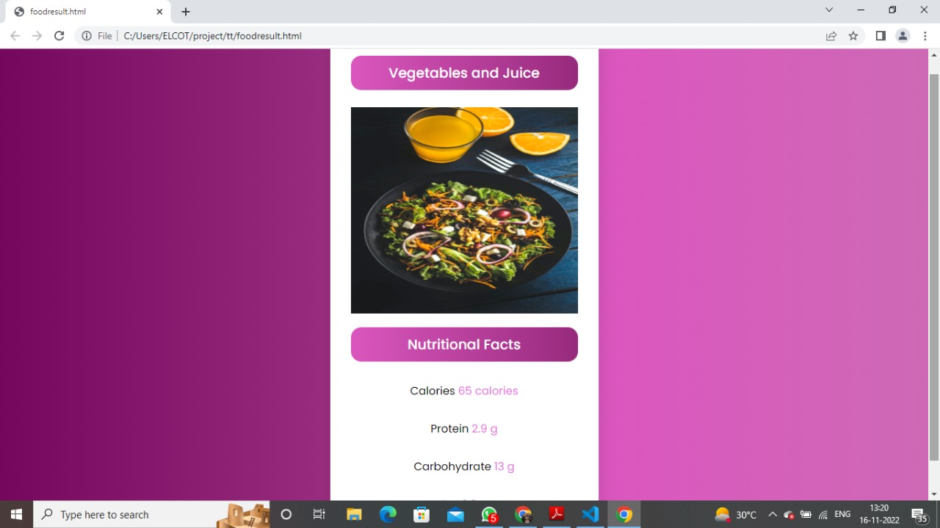

**History of Food Items Module**

# foodHistory.html

<div class="wrapper">

<div class="title-text">

<div class="title signup">History Food Items</div>

</div><br>

<div class="form-container">

<div class="form-inner">

<form action="#" class="login">

<ol class="stepper">

<li class="stepper-item complete">

<span class="stepper-counter"></span>

<a href="#" class="stepper-link">

<span>Rava Upma</span>

</a>

<span class="stepper-line"></span>

</li>

<li class="stepper-item complete">

<span class="stepper-counter"></span> <a href="#" class="stepper-link">

<span>Rava Idli</span>

</a>

<span class="stepper-line"></span>

</li>

<li class="stepper-item">

<span class="stepper-counter"></span> <a href="#" class="stepper-link">

<span>Omelette</span>

</a>

<span class="stepper-line"></span>

</li>

<li class="stepper-item">

<span class="stepper-counter"></span>

<a href="#" class="stepper-link">

<span>Moong Dal Chilla</span>

</a>

<span class="stepper-line"></span>

</li>

<li class="stepper-item">

<span class="stepper-counter"></span>

<a href="#" class="stepper-link">

<span>Beetroot dosa</span>

</a>

<!-- <span class="stepper-line"></span> -->

</li> </ol>

<div class="field btn">

<div class="btn-layer"></div>

<input type="submit" value="Traker">

</div>

<div class="signup-link">Calories Limit <a href="">2,500</a></div>

<div class="signup-link">Total Calories Consumed <a href="">3000</a></div>

<div class="signup-link">Calories Left <a href="">500</a></div>

</form>

</div>

</div>

</div>

# fohi.css

@import url('https://fonts.googleapis.com/css?family=Poppins:400,500,600,700&display=swap');

*{ margin: 0; padding: 0; box-sizing: border-box; font-family: 'Poppins', sans-serif;

}

html,body{

display: grid; height: 100%; width: 100%; place-items: center;

background: -webkit-linear-gradient(left, #003366,#004080,#0059b3

, #0073e6);

}

::selection{ background: #1a75ff;

color: #fff;

}

.wrapper{ overflow: hidden; max-width: 390px; background: #fff; padding: 30px; border-radius: 15px; box-shadow: 0px 15px 20px rgba(0,0,0,0.1);

}

.wrapper .title-text{ display: flex; width: 200%;

}

.wrapper .title{ width: 50%; font-size: 35px; font-weight: 600; text-align: center; transition: all 0.6s cubic-bezier(0.68,-0.55,0.265,1.55);

}

.wrapper .slide-controls{ position: relative; display: flex; height: 50px; width: 100%; overflow: hidden; margin: 30px 0 10px 0; justify-content: space-between; border: 1px solid lightgrey; border-radius: 15px;

}

.slide-controls .slide{ height: 100%; width: 100%; color: #fff; font-size: 18px; font-weight: 500; text-align: center; line-height: 48px; cursor: pointer; z-index: 1;

transition: all 0.6s ease;

}

.slide-controls label.signup{ color: #000;

}

.slide-controls .slider-tab{ position: absolute; height: 100%; width: 50%;

left: 0; z-index: 0; border-radius: 15px; background: -webkit-linear-gradient(left,#003366,#004080,#0059b3

, #0073e6); transition: all 0.6s cubic-bezier(0.68,-0.55,0.265,1.55);

}

input[type="radio"]{

display: none;

}

#signup:checked ~ .slider-tab{ left: 50%;

}

#signup:checked ~ label.signup{ color: #fff; cursor: default; user-select: none;

}

#signup:checked ~ label.login{ color: #000;

}

#login:checked ~ label.signup{ color: #000;

}

#login:checked ~ label.login{ cursor: default; user-select: none;

}

.wrapper .form-container{ width: 100%; overflow: hidden;

}

.form-container .form-inner{ display: flex; width: 200%;

}

.form-container .form-inner form{ width: 50%; transition: all 0.6s cubic-bezier(0.68,-0.55,0.265,1.55);

}

.form-inner form .field{ height: 50px; width: 100%; margin-top: 20px;

}

.form-inner form .field input{ height: 100%; width: 100%; outline: none; padding-left: 15px; border-radius: 15px; border: 1px solid lightgrey; border-bottom-width: 2px; font-size: 17px; transition: all 0.3s ease; .form-inner form .field input:focus{ border-color: #1a75ff;

/* box-shadow: inset 0 0 3px #fb6aae; */

}

.form-inner form .field input::placeholder{ color: #999; transition: all 0.3s ease;

} form .field input:focus::placeholder{

color: #1a75ff;

}

.form-inner form .pass-link{ margin-top: 5px;

}

.form-inner form .signup-link{ text-align: center; margin-top: 30px;

}

.form-inner form .pass-link a,

.form-inner form .signup-link a{ color: #1a75ff; text-decoration: none;

}

.form-inner form .pass-link a:hover,

.form-inner form .signup-link a:hover{ text-decoration: underline;

}

form .btn{

height: 50px; width: 100%; border-radius: 15px; position: relative; overflow: hidden;

} form .btn .btn-layer{

height: 100%; width: 300%; position: absolute; left: -100%; background: -webkit-linear-gradient(right,#003366,#004080,#0059b3

, #0073e6); border-radius: 15px; transition: all 0.4s ease;; form .btn:hover .btn-layer{ left: 0;

}

form .btn input[type="submit"]{

height: 100%; width: 100%; z-index: 1; position: relative; background: none; border: none; color: #fff; padding-left: 0; border-radius: 15px; font-size: 20px; font-weight: 500; cursor: pointer;

}

body {

display: grid; height: 100vh; place-items: center;

}

input::file-selector-button {

background-image: linear-gradient( to right, #ff7a18,

#af002d,

#319197 100%,

#319197 200%

);

background-position-x: 0%; background-size: 200%; border: 0; border-radius: 8px; color: #fff;

padding: 1rem 1.25rem; text-shadow: 0 1px 1px #333; transition: all 0.25s;

} input::file-selector-button:hover {

background-position-x: 100%; transform: scale(1.1);

@import url("https://fonts.googleapis.com/css2?family=Outfit:wght@100;200;300;400;500;600;700;800;9 00&display=swap");

*,

*:before,

*:after { box-sizing: border-box;

}

/* Some basic CSS overrides */ body { line-height: 1.5; min-height: 100vh; font-family: "Outfit", sans-serif; display: grid; place-content: center; padding: 2rem;

background-color: #eff6ff;

}

button, input, select, textarea { font: inherit;

}

a {

color: inherit;

}

/* End basic CSS override */

:root {

--c-primary: #1d4ed8;

--c-secondary: #dbeafe;

--c-stepper-bg: #fff;

}

.stepper { display: flex; flex-direction: column; counter-reset: stepper; gap: 8px;

border: 2px solid var(--c-secondary); background-color: var(--c-stepper-bg); padding: 2rem; border-radius: 10px;

}

.stepper-item { display: grid; grid-template-rows: [text-row] auto [line-row] 20px; grid-template-columns: [counter-column] 28px [text-column] auto; column-gap: 16px; row-gap: 8px; position: relative; &.complete {

.stepper-counter { background-color: var(--c-secondary); color: var(--c-primary); position: relative;

&:after { position: absolute; content: ""; display: block; width: 16px; height: 16px; border-radius: 50%; background-color: var(--c-stepper-bg); right: -6px; bottom: -6px; background-image: url("data:image/svg+xml,%3Csvg

xmlns='http://www.w3.org/2000/svg' viewBox='0 0 24 24' width='24' height='24'%3E%3Cpath fill='none' d='M0 0h24v24H0z'/%3E%3Cpath fill='%231d4ed8' d='M10 15.172l9.192-9.193 1.415 1.414L10 18l-6.364-6.364 1.414-1.414z'/%3E%3C/svg%3E"); background-size: 12px; background-repeat: no-repeat; background-position: center center;

}

}

}

&:last-child { grid-template-rows: [text-row] auto;

}

}

.stepper-line { display: block; width: 2px; background-color: #8f8f8f; height: 100%;

justify-self: center;

.stepper-item:last-child & { display: none;

}

}

.stepper-counter { flex-shrink: 0; counter-increment: stepper;

&:before { content: counter(stepper);

} display: flex; align-items: center; justify-content: center; width: 28px; height: 28px; background-color: var(--c-primary); color: #fff;

border-radius: 50%; line-height: 1;

}

.stepper-link { display: flex; gap: 12px; text-decoration: none; color: var(--c-primary);

span { padding-top: calc((28px - 1.5em) / 2); font-weight: 600;

border-bottom: 2px solid transparent;

}

&:after { content: ""; position: absolute; top: 0;

left: 0; right: 0; bottom: 0;

}

&:hover { span { border-color: currentcolor;

}

}

&:focus { outline-offset: 4px; outline-color: var(--c-primary); outline-width: 2px; border-radius: 4px;

}

}

